This document provides a step-by-step walkthrough for enrolling in and withdrawing from courses, and for tracking your personal transcript, in the truenorthlogic portal. Your portal view will reflect your district’s specific naming convention and configuration choices.

* To begin, log into your truenorthlogic account and click the **Professional Learning** tab.



# Searching For Courses

* In the **Search** channel, type the course name of the course in the search field and click enter

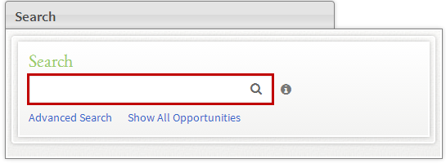

* A list of all matching learning opportunities displays.
* The course title appears on the left. Course registration buttons appear on the right.

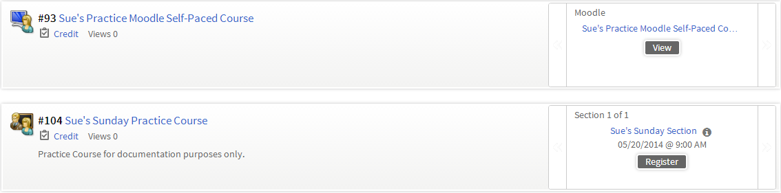

**Note:** Self-paced Learning Opportunities display a **View** button. Instructor Led Learning Opportunities display a **register** button.

* Click **Show All Opportunities** to display a list of all available learning opportunities.

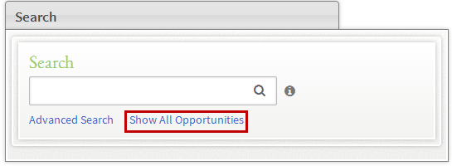

* Click **Advanced Search** to conduct a more detailed search.

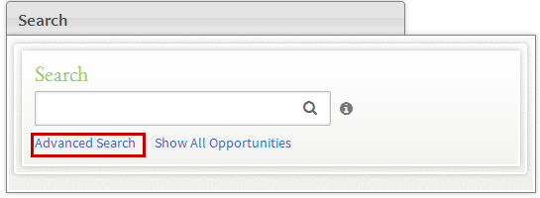

Complete the form and click **Search.**

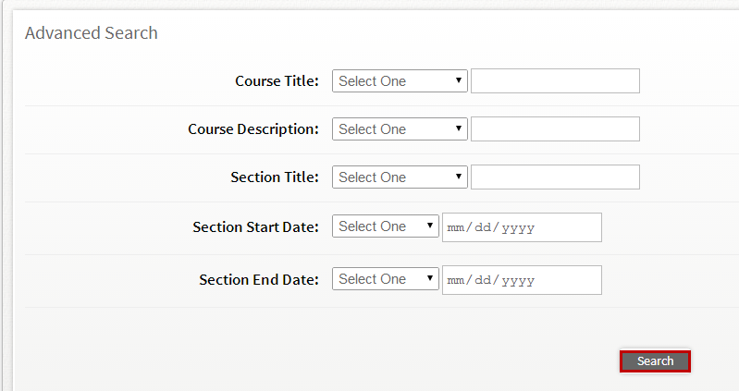

## Required or Recommended Trainings

* Any courses you are required to take will appear in your **Required Trainings** channel.
* Recommended courses will appear in your **Recommended Trainings** channel.
* Click the title of the course to view course details.

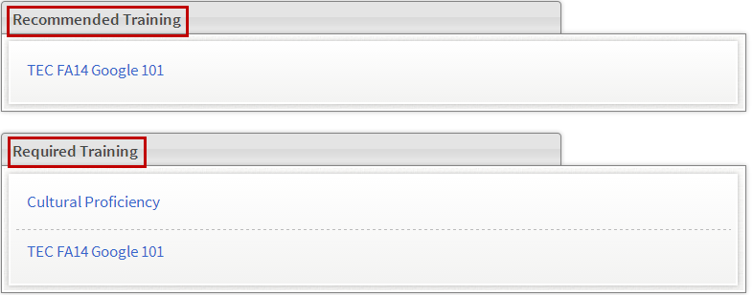

* Scroll down to the **Aligned Subjects** channel to view courses that have been aligned to specific subjects.
* Click the subject link to view a list of all courses aligned to that subject.

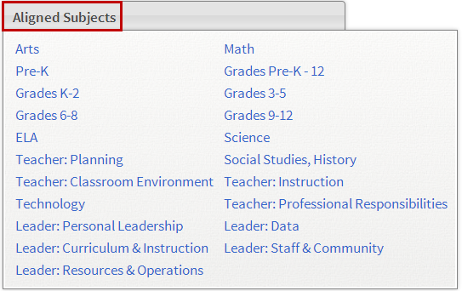

* A list of all subject-aligned courses will display.

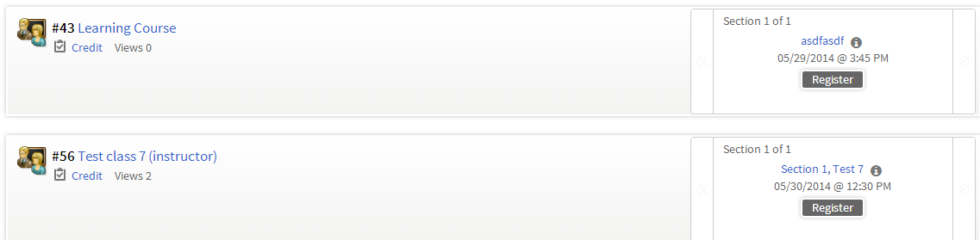

# Enrolling in a Courses

* Once you’ve located the course in which you wish to enroll, and click **Register** for an instructor led learning opportunity, or **View** for a self-paced learning opportunity.

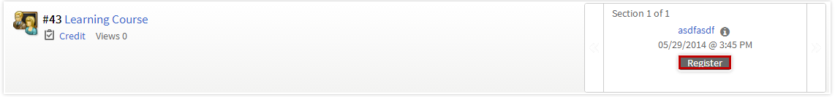

* Review course and section details and click **Next.**

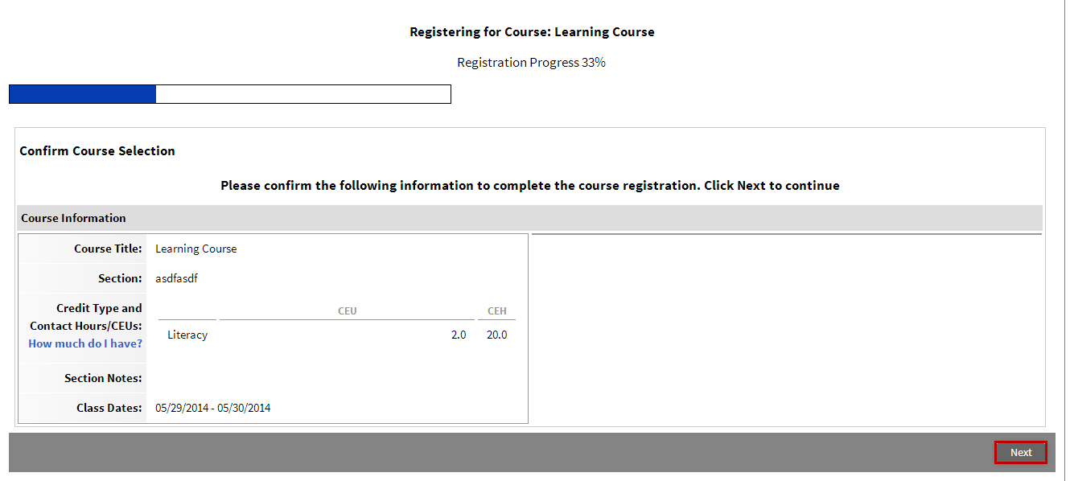

* This completes the registration process.
  + Click **My Course List** to view a list of courses for which you’ve registered.
  + Click **Course Search** to search for additional courses.
  + Click **Learning Opportunity** to view details for this course.

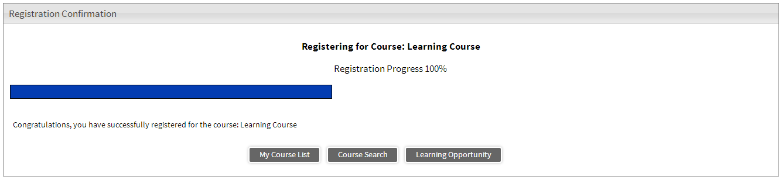

# Withdrawing From Learning Opportunities

* To withdraw from a learning opportunity, navigate to the **My Courses** channel and click **Search**.

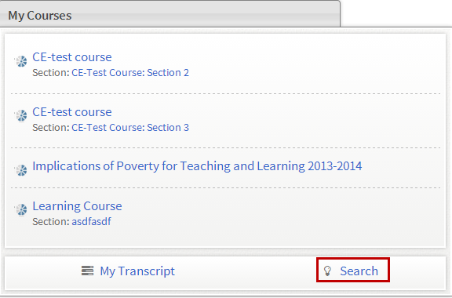

* A list of all learning opportunities into which you are currently enrolled will display.
* Locate the learning opportunity from which you wish to withdraw and click **Actions.**

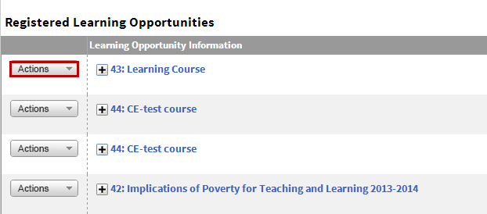

* From the dropdown, click **Withdraw.**

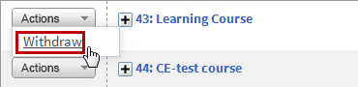

* Click **Withdraw** again to remove yourself from the course.



* Click **OK** to return to your list of registered learning opportunities.

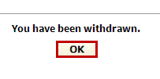

# Transcripts

* To access and view transcripts, scroll to the **My Courses** channel and click **My Transcript.**

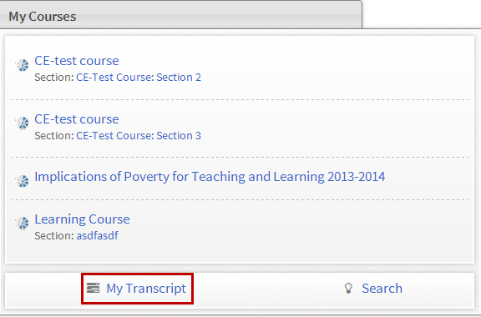

* Your current transcript will display. Use the calendar tool to search for transcript details within a date range and click **Search**.
* Click **Email Pdf** to email a copy of your transcript to selected users.
* Click **Print** to download and print a copy of your transcript.

